**Green Society Public School**

**Ratnanagar-7, Sauraha, Chitwan**

**Second Terminal Examination-2082**

**Class: Three Time: - 1 hr. F.M.: 25**

**Sub: Computer**

|  |
| --- |
| **Name: Roll No.: Sec.:** |
| **­­­­­­­­­­­­ ________________ ______________ OBT.MARKS:**  **INVIGILATOR EXAMINER** |

# Fill in the blanks. (4×1=4)

[icons, keyboard, softcopy, automatic]

a) __________ are the small pictures that appear on the Desktop.

b) The output shown on the monitor is called __________.

c) __________ is used to enter data and instruction into a computer.

d) Computer is ________________________.

# 2. Write T for True or F for False statements. (4×1=4)

a) Computers have very small memory.

b) CPU is fixed inside the system unit.

c) Cursor is the blinking line on the screen.

d) A desktop is a box-like frame with documents, toolbars, programs and icons.

# 3. Match the following. (3×1=3)

a) Data - i) calculation and processing

b) CPU - ii) The collection of raw -facts

c) Mouse - iii) A pointing device used to point and click

# 4. Rearrange the following jumbled words. (3×1=3)

a) EDLTEE EKY __________

b) CPSVE RBAO __________

c) topksed __________

# 5. Identify the pictures. (5×1=5)

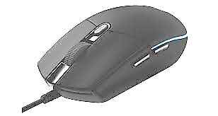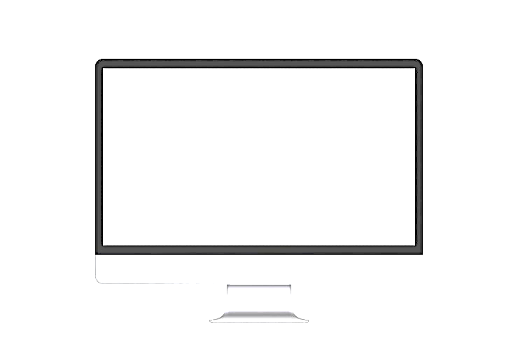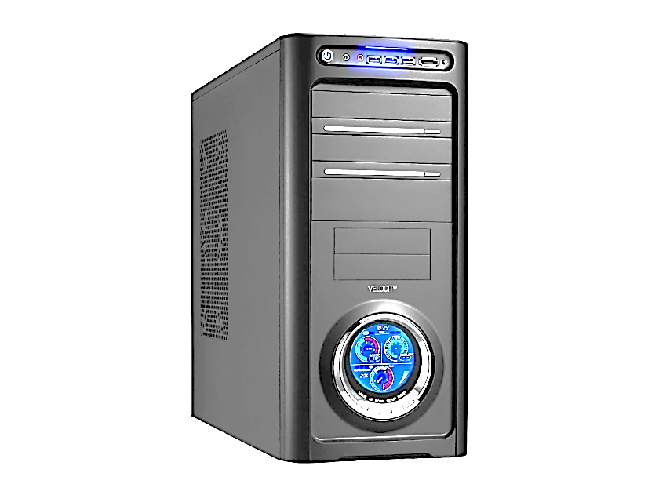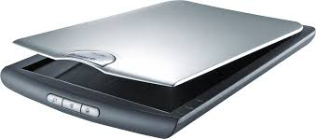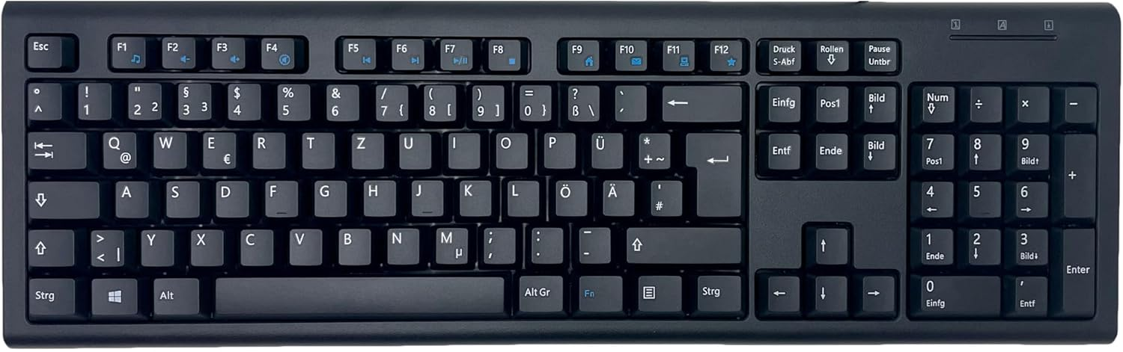

# 6. Answer the following questions. (Any 3) (3×2=6)

# a) What is Microsoft Windows?

_________________________________________________________________

b) What are alphabet keys?

_________________________________________________________________

c) What is an optical disk?

_________________________________________________________________

d) Define data.

_________________________________________________________________

**The End**